Denbighshire County Council Logo

# Check an Open Ended Employee Sickness Absence

1. Open iTrent Electric
2. Click on People in your main menu.

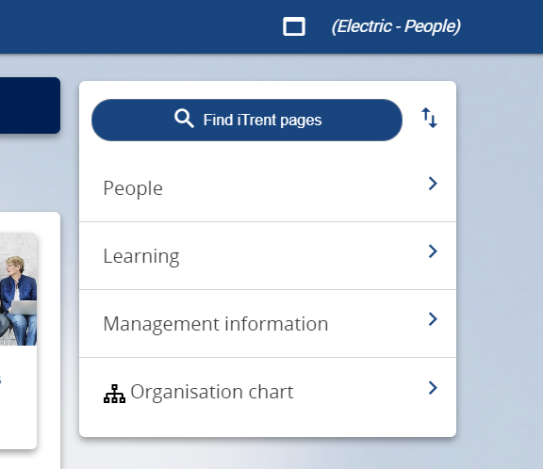

1. Select the employee from your list of reporting employees or by searching for the employee (as shown in the following image).

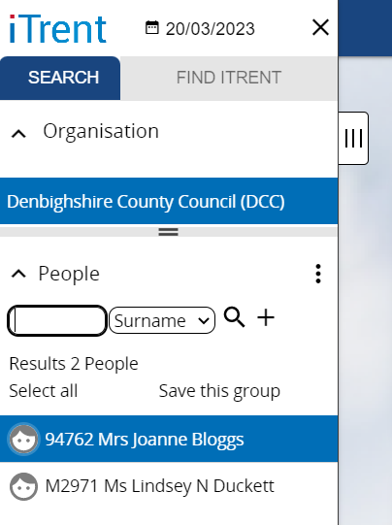

The person summary card will display.

1. Click on the Sickness Absence folder in the LINKS section of the person summary card (the LINKS section is at the bottom).
2. Click on “Sickness Absence details”

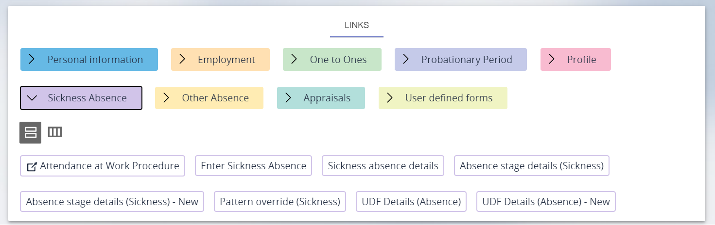

1. Select the sickness absence you want to end from the list that appears in the menu on the left of the screen

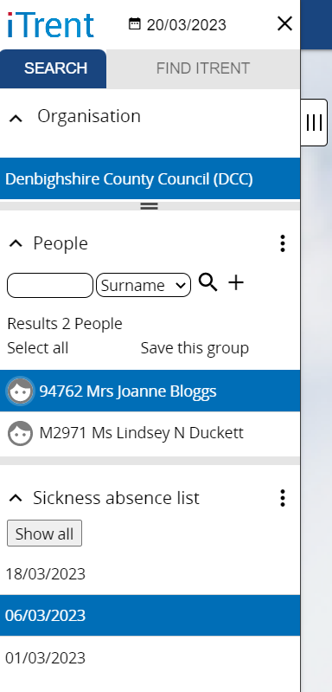

The Sickness Absence form then opens as shown in the following image.

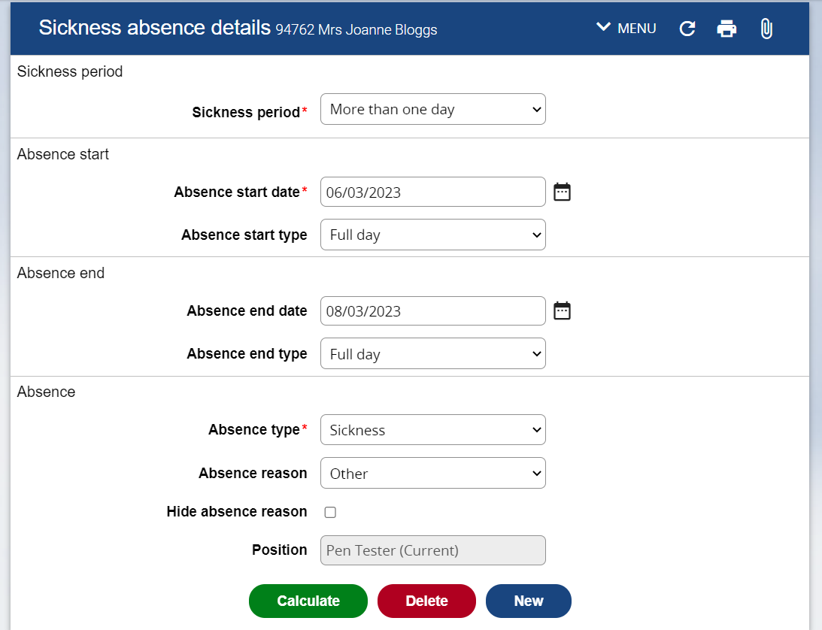

1. Click on Calculate
2. Open the Main Menu on the left (by clicking on the tab with three vertical lines on the edge of the menu) and scroll across to see the updated working days lost.