Denbighshire County Council Logo

# How to Enter Fit for Work Details in iTrent Electric

## Enter a New Fit for Work

1. Open iTrent Electric
2. Click on People in your main menu.

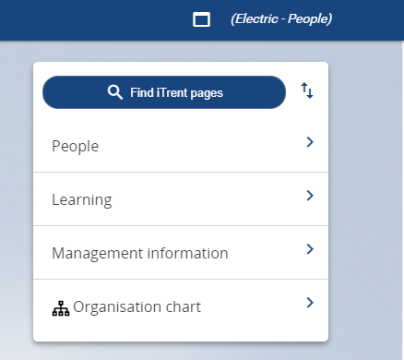

1. Select the employee from your list of reporting employees or by searching for the employee (as shown in the following image).

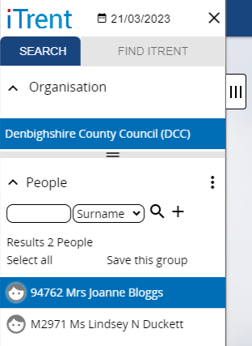

The person summary card will display.

1. Click on the Sickness Absence folder in the LINKS section of the person summary card (the LINKS section is at the bottom).
2. Click on “Sickness Absence details”
3. Select the sickness absence you want to end from the list that appears in the menu on the left of the screen

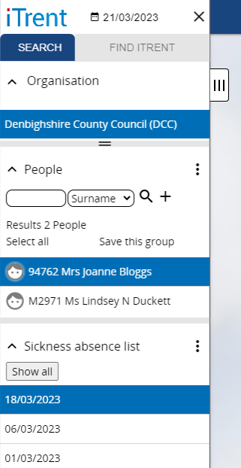

Please note this menu can be expanded for further details (if required) by clicking on the tab with three vertical lines on the edge of the menu.

The Sickness Absence form then opens as shown in the following image.

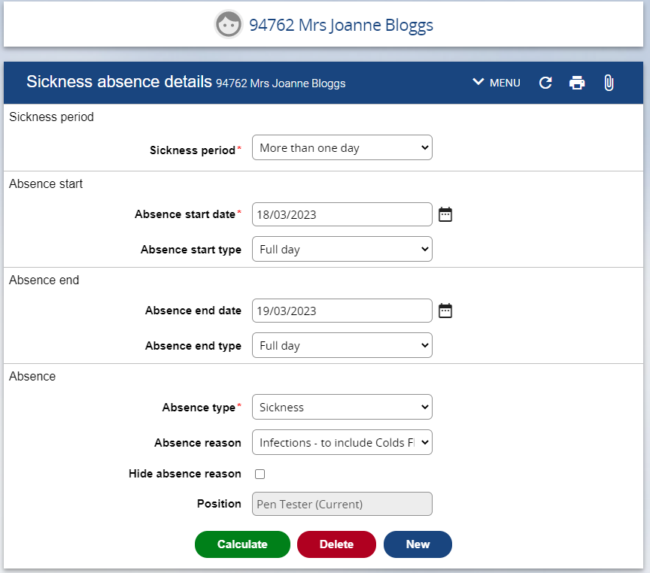

1. Click on the Paperclip in the Sickness Absence Details Banner



It is the very last icon on the right.

1. Select UDF Categories

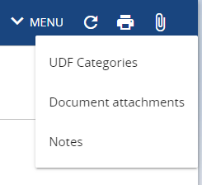

The Statement of Fitness for Work form opens as follows:

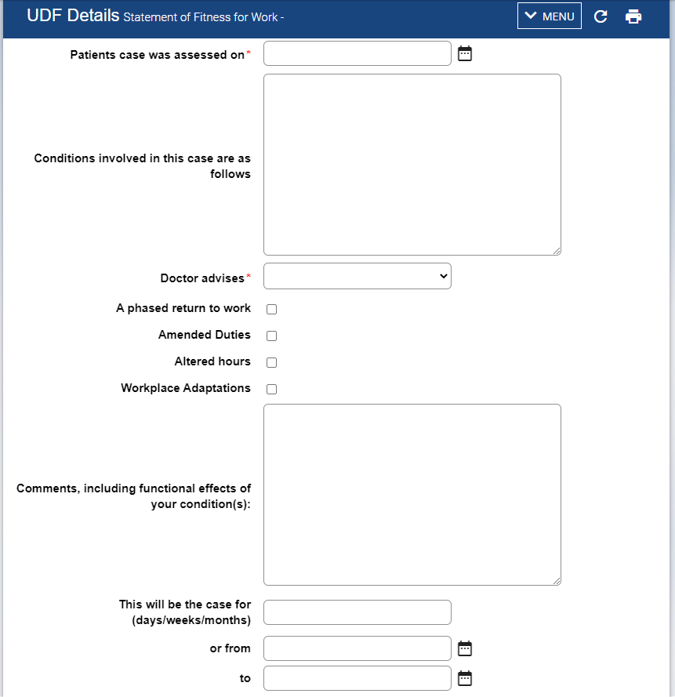

1. Enter the details as required:

* Dates are entered DD/MM/YY or selected from the calendar buttons
* Mandatory fields are indicated by a blue dot

1. Click Save

## Enter Additional Fit for Work Statement Details

1. Click on UDF categories.
2. Select the latest existing Statement in the menu on the left.

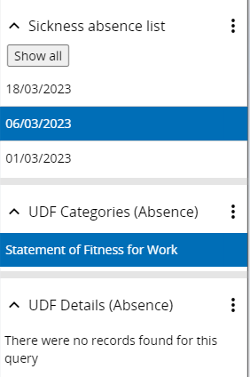

1. Click on the New button at the bottom of the form:

Click on the New button at the bottom of the form:

1. Enter details
2. Save