Denbighshire County Council Logo

# How to Enter Other Absence Details in iTrent Electric

1. Open iTrent Electric
2. Click on People in your main menu.

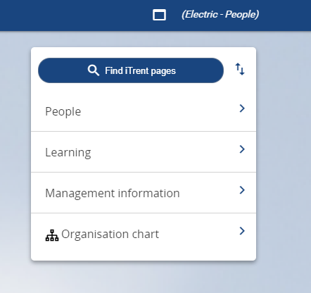

1. Select the employee from your list of reporting employees or by searching for the employee (as shown in the following image).

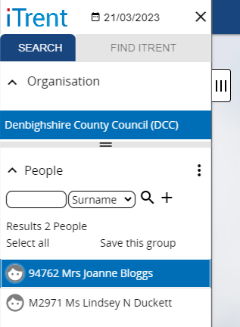

The person summary card will display.

1. Click on the Other Absence folder in the LINKS section of the person summary card (the LINKS section is at the bottom).
2. Click on “Other absence details - New”

The form opens as shown in the following image.

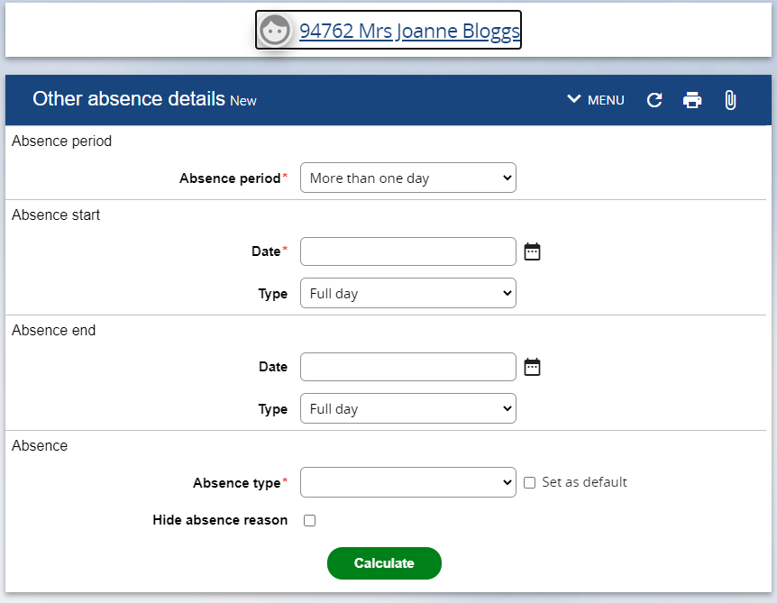

1. Select the Absence Period from the dropdown menu e.g. More than one day or Full day.

Please note if Part day is selected further detail becomes available and you enter the number of hours absent or if it is a morning or afternoon.

1. Enter the Absence start date DD/MM/YY or select from calendar button
2. Enter the Absence end date (if necessary).
3. Select the Absence type from the dropdown menu e.g. Flexi Leave
4. Click on Calculate