Denbighshire County Council Logo

# How to Enter Sickness Absence Details in iTrent Electric

## Starting a Sickness Absence

1. Open iTrent Electric
2. Click on People in your main menu.

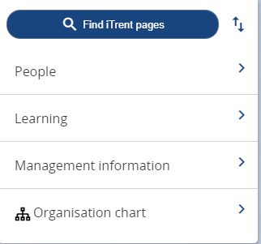

1. Select the employee from your list of reporting employees or by searching for the employee (as shown in the following image).

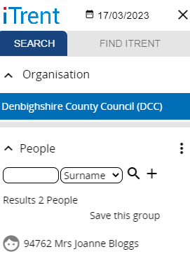

The person summary card will display.

1. Click on the Sickness Absence folder in the LINKS section of the person summary card (the LINKS section is at the bottom).
2. Click on “Enter Sickness Absence”

The form opens as shown in the following image.

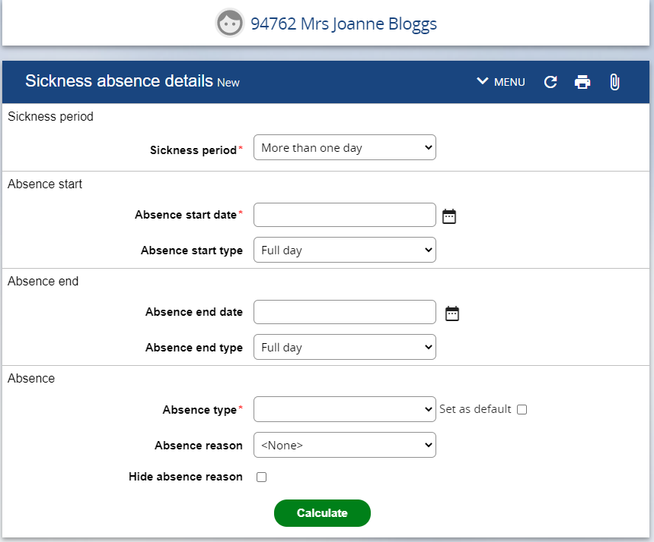

1. Select the Absence Period from the dropdown menu e.g. More than one day or Full day.

Please note if Part day is selected further detail becomes available and you select Half Day – PM or Half Day – AM. It is also possible to select Half Day – PM in the Absence start type if the absence is ‘More than one day’ and the employee worked part of the day they began their sickness absence.

1. Enter the Absence start date DD/MM/YY or select from calendar button
2. Enter the Absence end date (if necessary).
3. Select the Absence type from the dropdown menu e.g. ‘Sickness’ or ‘Sickness – Disability Related’ etc.
4. Select the Absence reason from the dropdown menu.
5. Click on Calculate

Please note that clicking on Calculate saves the absence.

## Ending a Sickness Absence

1. Open iTrent Electric
2. Click on People in your main menu.

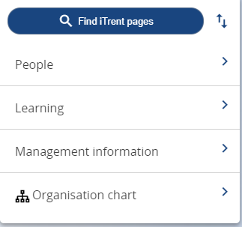

1. Select the employee from your list of reporting employees or by searching for the employee (as shown in the following image).

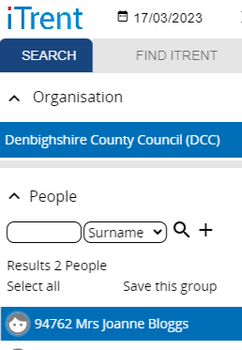

The person summary card will display.

1. Click on the Sickness Absence folder in the LINKS section of the person summary card (the LINKS section is at the bottom).
2. Click on “Sickness Absence details”
3. Select the sickness absence you want to end from the list that appears in the menu on the left of the screen

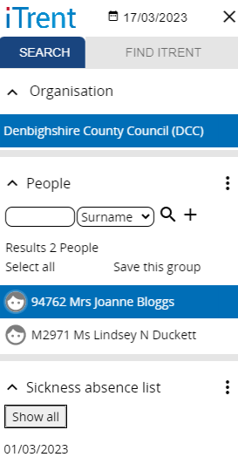

Please note this menu can be expanded for further details (if required) by clicking on the tab with three vertical lines on the edge of the menu.

The Sickness Absence form then opens as shown in the following image.

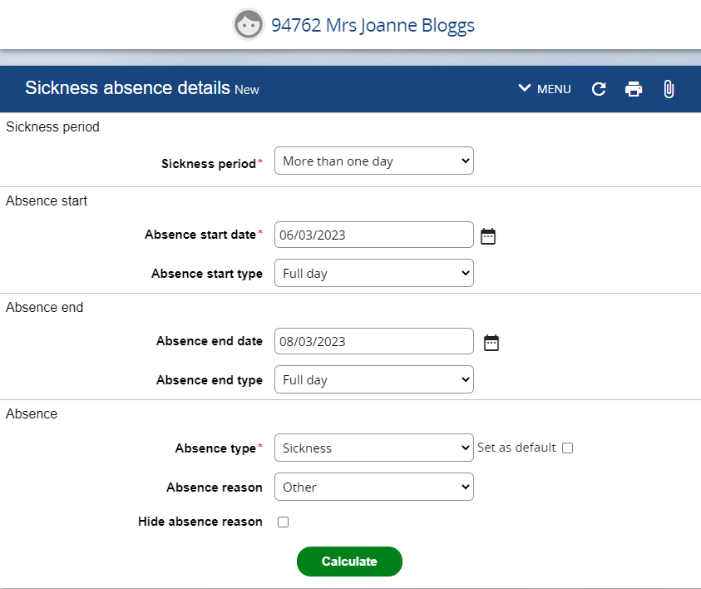

1. Enter the absence end date
2. Select the absence end type from the drop down list (if required.)
3. Click on Calculate.

## Complete a Pattern Override

If the system does not have the correct working pattern for the employee the ‘Days Lost’ for the sickness absence will not calculate correctly. The working pattern can be overridden in order to correct this as a ‘one off’ to correct the days lost but please also inform HR who will correct the pattern on a permanent basis.

1. Open the sickness absence
2. Click on the down arrow next to MENU in the Sickness absence details banner.

Open the sickness absence

1. Select Pattern override (Sickness)

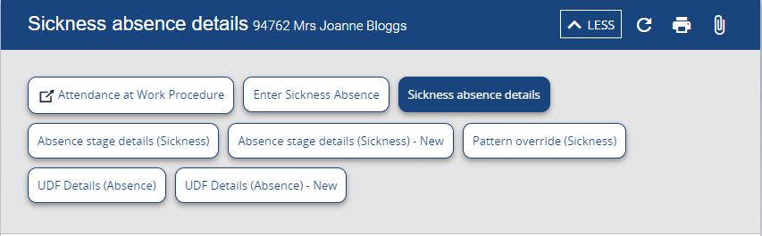

The Pattern override form opens as follows:

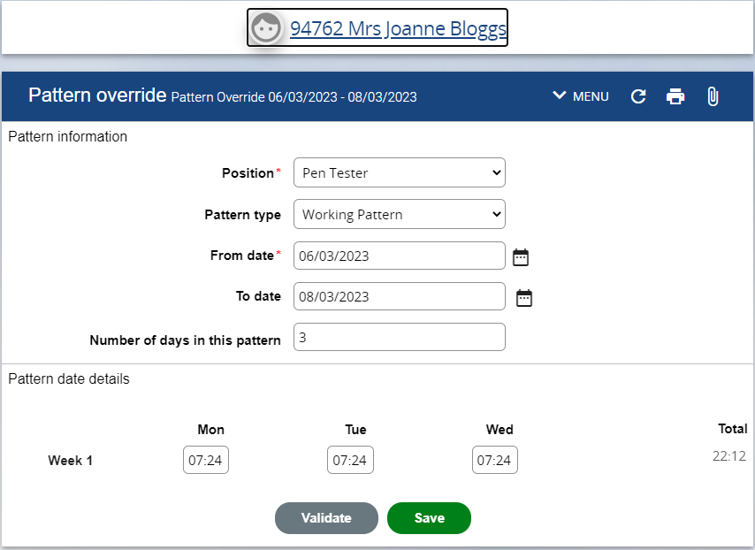

1. Amend the days as necessary
2. Click Validate to check the Total (if required)
3. Click Save
4. Recalculate the sickness absence if required.