Denbighshire County Council Logo

# Using the Employee Absence Calendar

1. Click on VIEW FULL CALENDAR in the Calendar section of the Person Summary card.

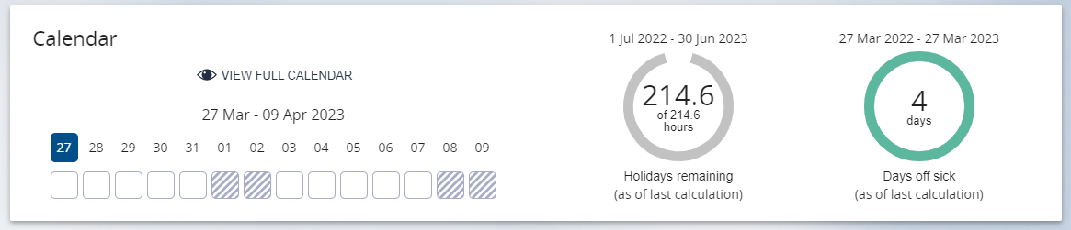

1. Right Click on a day in the row next to the employee name and a new menu will display you will be presented with options such as; create a sickness or other absence; update or delete an existing absence.

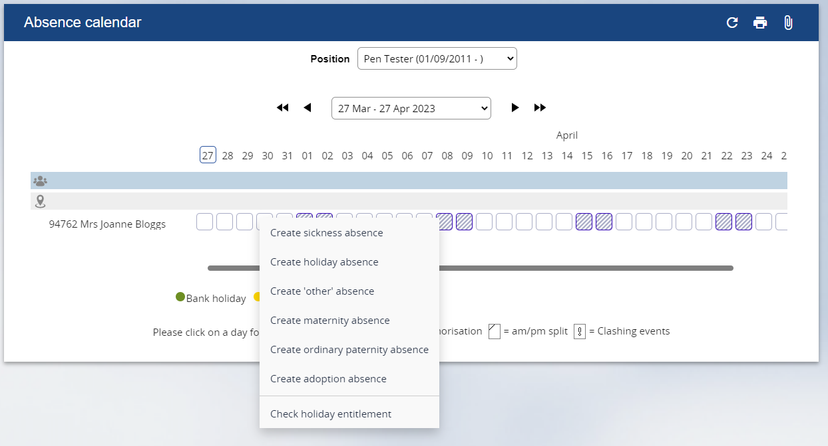

1. Select the option for the necessary action and the appropriate for will appear. For example, the sickness absence details form.
2. Edit
3. Save or Calculate
4. Return to the Absence Calendar by clicking on the crumb trail menu next to the employee name (<Absence calendar):

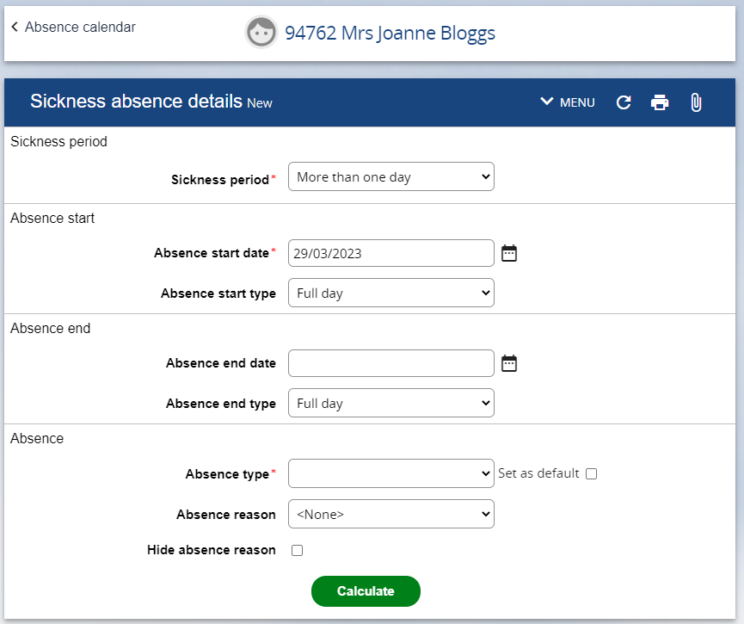

1. To return to the Person Summary click on the employee name at the top of the screen.
2. To refresh the information in the Person Summary click on the circular arrow to the right of the employee name.

