Denbighshire County Council Logo

# Complete Probationary Period Review Stages

1. Open iTrent Electric
2. Click on People in your main menu.

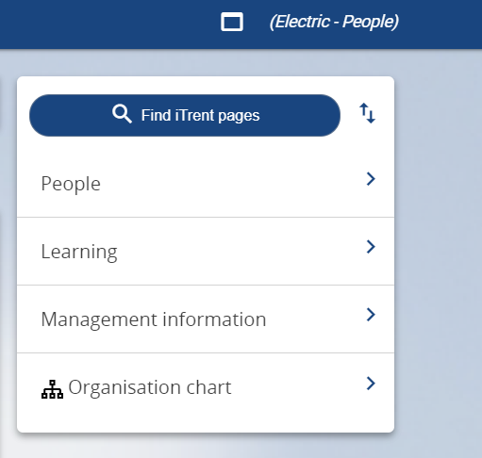

1. Select the employee from your list of reporting employees or by searching for the employee (as shown in the following image).

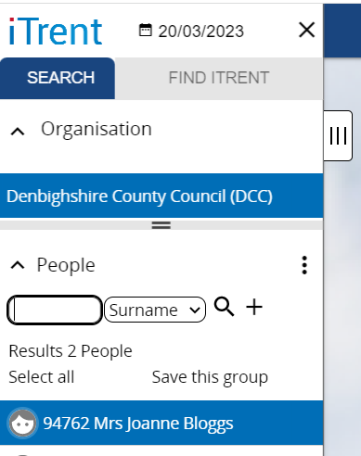

The person summary card will display.

1. Click on the Probationary Period folder in the LINKS section of the person summary card (the LINKS section is at the bottom).

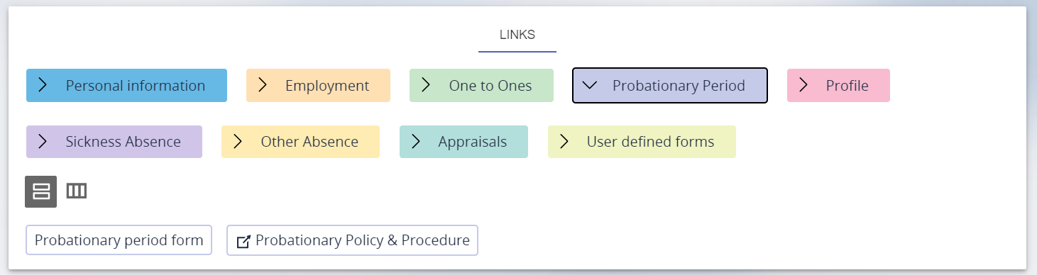

1. Click on “Probationary period form”

The Probationary Period Review form will open:

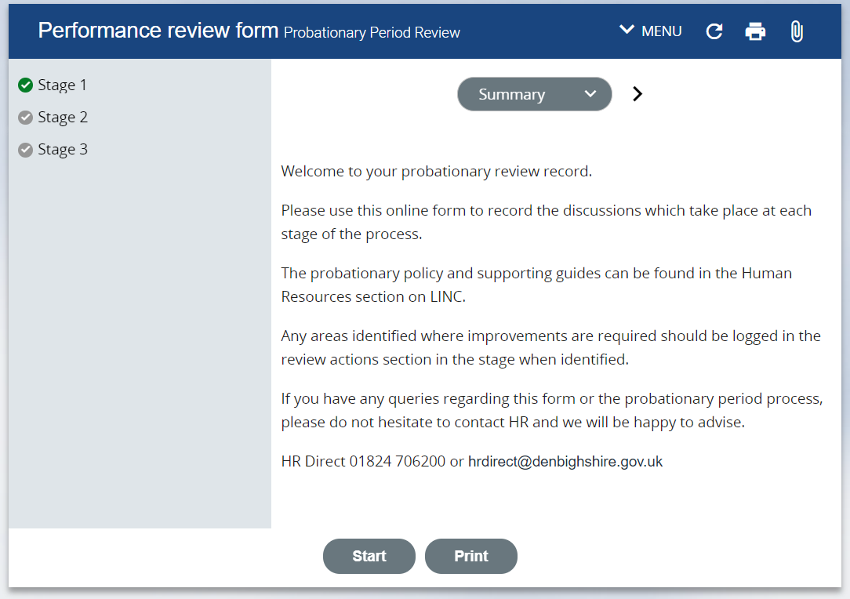

**If** the form fails to open please check in the main menu that the Adhoc performance Review and Probationary Period Review forms are highlighted – if the form is not highlighted please contact HR.

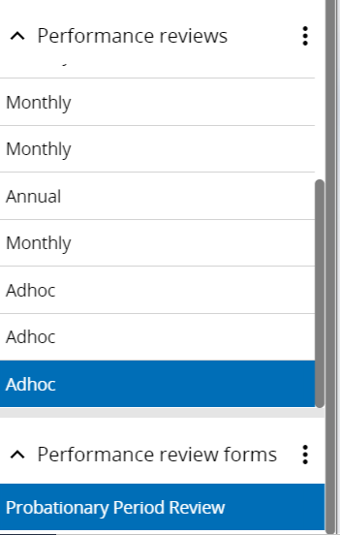

1. Click on the Stage that you want to complete the details for. E.g. Stage 1

The form will open showing the key dates at the top:

1. Enter the date the stage review is completed
2. Enter the date the stage review is completed

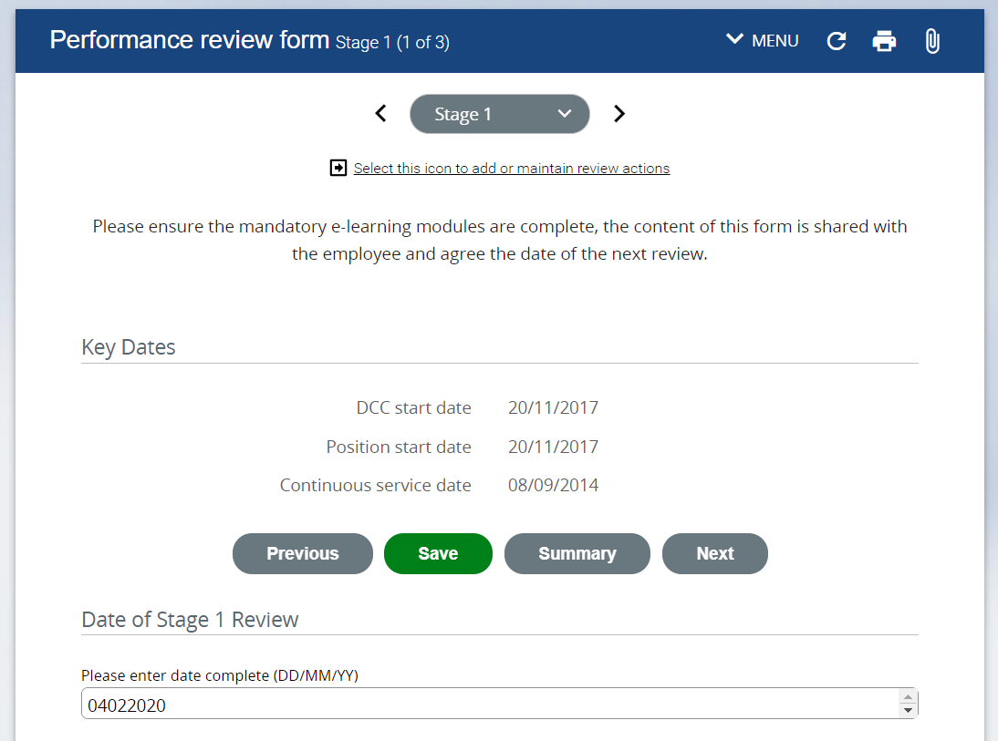

1. Use the Radio buttons to complete the Performance Areas section

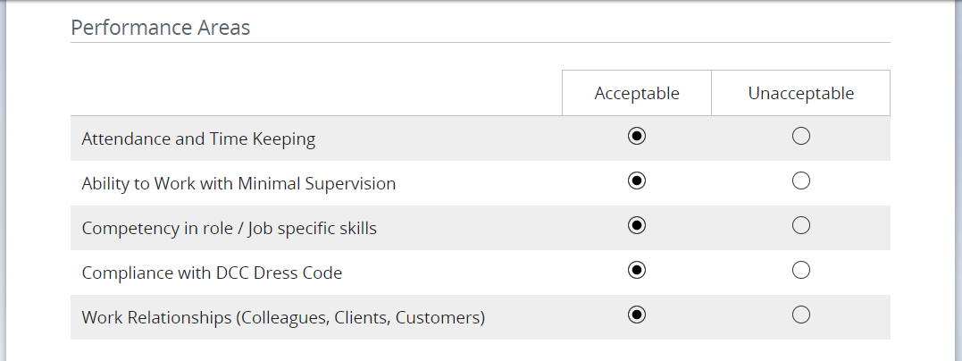

1. Expand the Skills by clicking on the right arrow before ‘Skills’ and review the skills which have been completed

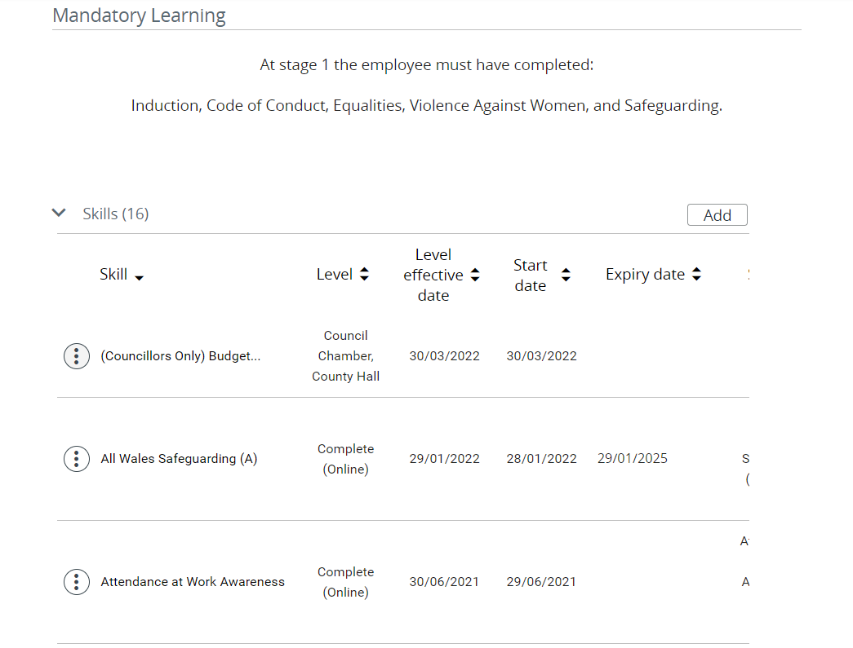

1. Tick the Check box if the learning for the stage has been completed

Tick the Check box if the learning for the stage has been completed

1. Complete the summary section and enter any comments you or the employee would like to make. 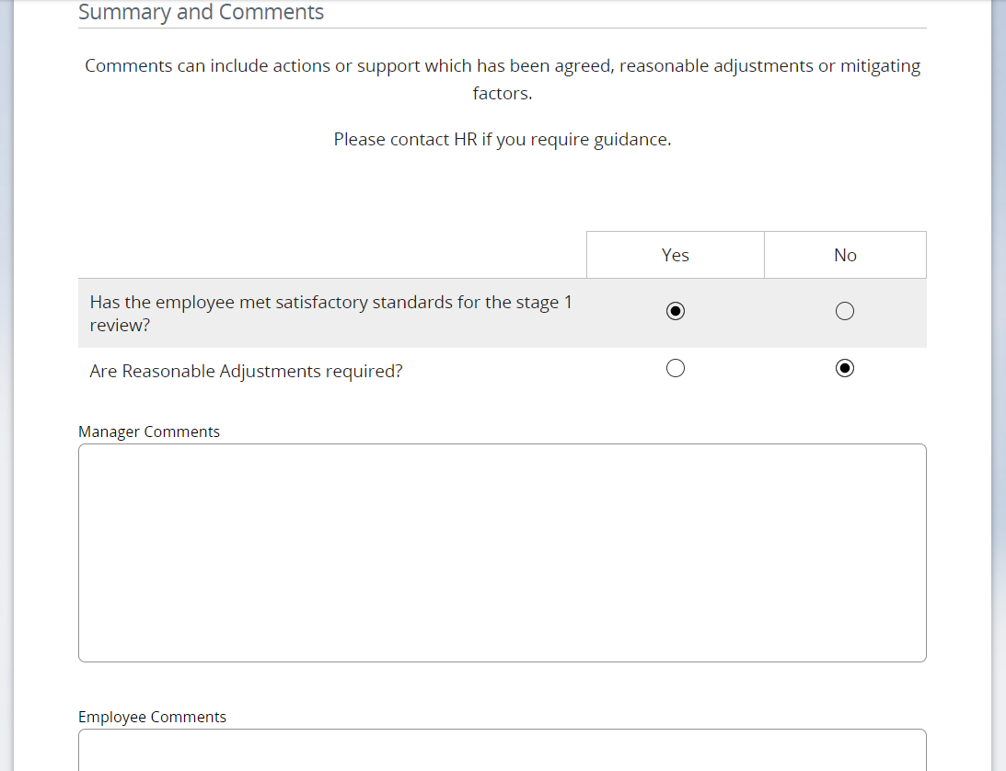
2. Click Save



1. Click on the employee name to return to the employee summary card.



1. Repeat these steps for all stages but do **not** submit the form until all 3 stages are complete and the final question is answered (Has the employee passed the probationary process?).

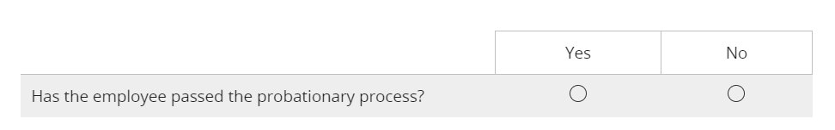

1. To submit the form return to the summary page of the form by selecting it in the grey drop down menu:

Image of stages drop down menu

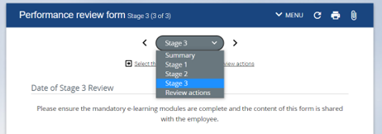

1. Click on Save.

