Denbighshire County Council Logo

# How to record One to One dates in iTrent Electric

1. Open iTrent Electric
2. Click on People in your main menu.

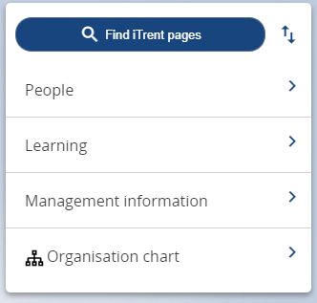

1. Select the employee from your list of reporting employees or by searching for the employee (as shown in the following image).

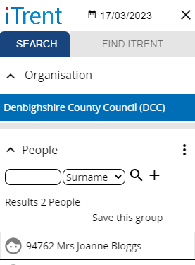

The person summary card will display.

1. Click on the One to One folder in the LINKS section of the person summary card (the LINKS section is at the bottom).
2. Click on “Enter One to One date or exception”

The form opens as shown in the following image.

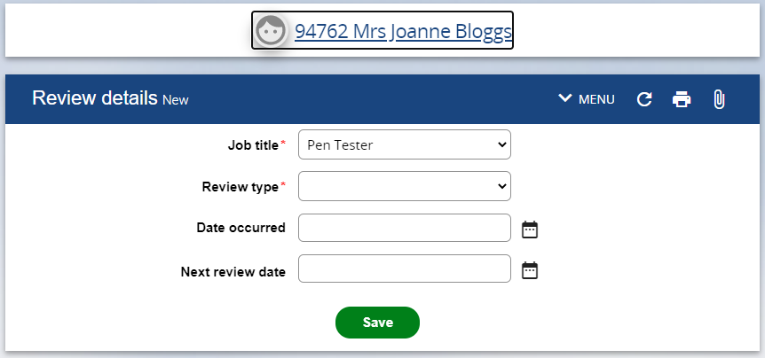

1. Select the Review Type from the dropdown menu e.g. One to Ones date only
2. Enter date occurred DD/MM/YY or select from calendar button
3. Enter next review date (optional) DD/MM/YY or select from calendar button.
4. Click on Save

Please note if you enter the next review date then this will appear in the employee summary card personal details as shown in the following image.

