Denbighshire County Council Logo

# View Information in the Recruitment Summary

If you are the recruiting manager for a vacancy you can view the latest information in the recruitment summary screens.

1. Open iTrent Electric
2. Select the role Electric – Recruitment
3. Click on Recruitment

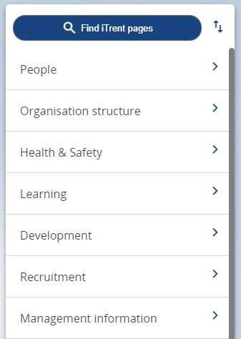

1. The Recruitment Summary Screen will open and show your open requisitions: 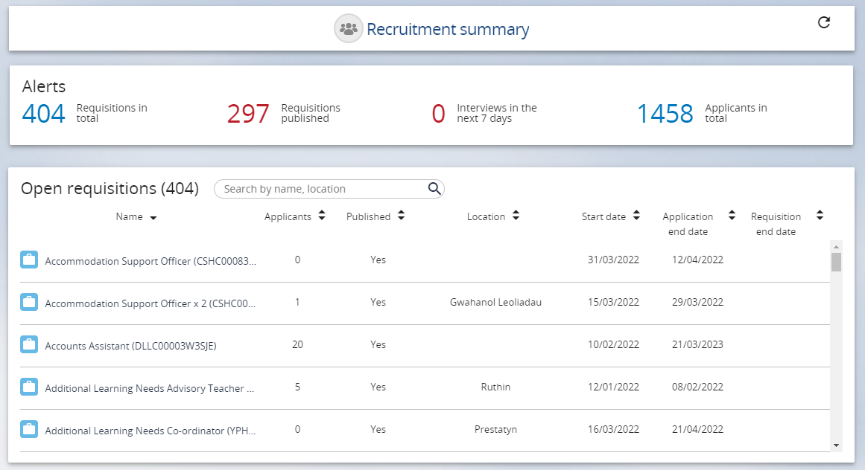
2. Click on the name of the requisition you want to see further information about. The vacancy summary screen will open:

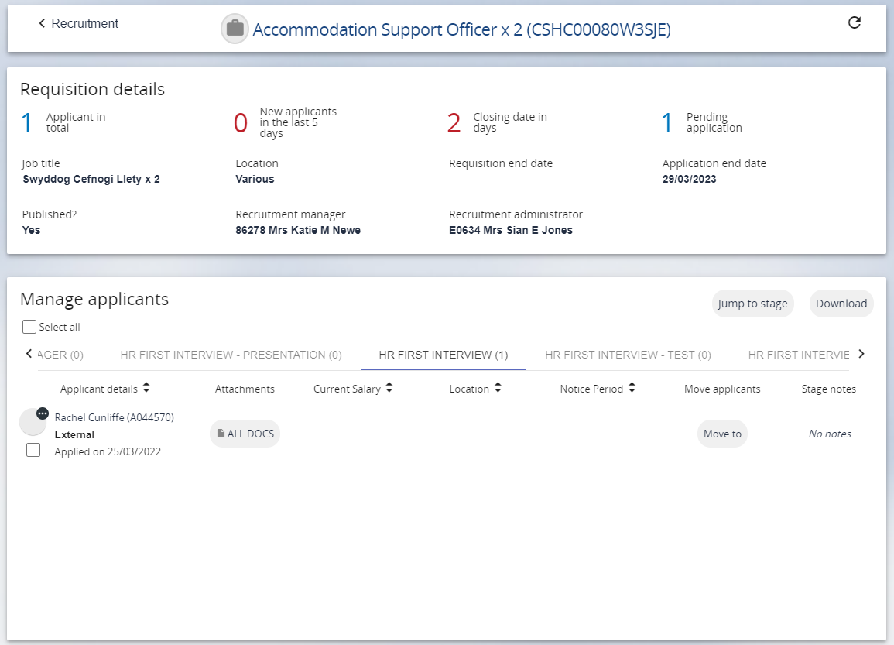

1. To view an application scroll to the stage where the applicant is click on All Docs next to the applicant name.

Please note: The number of applicants in each stage is shown in brackets at the end of each stage.

1. Select Application Print (NB: This will open the document for printing rather than print)
2. Open